1.3 Functions and Their Representations

Basic Concepts and Function Notation

A function is a mathematical rule that associates a unique output value to each input value. This means that if you provide the same input to a function, you will always get the same output.

Example

Lightning causes thunder. However, we often see a flash of lightning before we hear the thunder because sound travels slower than light. The distance between a lightning strike and an observer affects the time delay between seeing the flash and hearing the thunder.

The following table shows the estimated distance (in miles) between an observer and a lightning strike, based on the time (in seconds) between seeing the lightning and hearing the thunder.
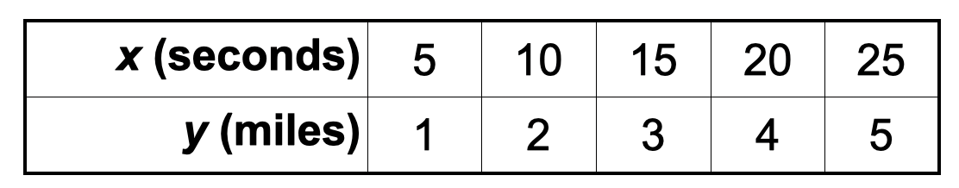
Question: Can you figure out the relationship between x and y?

Courtney saw the number 5.
Velincia said each mile adds 5 seconds.

x = 5y (Rule or relationship)

When y = 1, x = 5*1 = 5
When y = 2, x = 5*2 = 10

y = x/5 is equivalent to x = 5y

This calculation is represented by y = f(x) which is known as function notation. It is read as "y equals f of x." This notation indicates that the function f, when applied to the input x, produces the output y. In other words, f(Input) = Output.

f(x) = x/5

The function f takes the input and divides it by 5 to produce an output.
f(10) - what is the output when the input is 10?
y = f(x) = x/5
f(10) = 10/5 = 2
f(20) = 20/5 = 4

The variable y is called the dependent variable, and the variable x is called the independent variable.

A function computes exactly one output for each valid input.

Checkpoint:

g(x) = 2x + 5
"g multiplies the input by 2 and adds 5 to it"

What is g(3)?

g(3) = 2*3 + 5 = 6 + 5 = 11

Domain and Range of a Function
The set of all meaningful inputs x is called the domain of the function.
The set of corresponding outputs y is called the range of the function.

Question: In the previous example, what is the domain and range of the function?


domain: {5, 10, 15, 20, 25}
range: {1, 2, 3, 4, 5}
Based on the table alone

Representation of Functions

Functions can be represented by

- Verbal Representations (Words)
- Numerical Representation (Table of Values)
- Symbolic Representation (Formula)
- Graphical Representation (Graph)

Question: Go back to the lightning example, how would you verbally represent that function?

Numerical Representation

Here is another numerical representation of the same example. Note that this is a partial representation of the function.
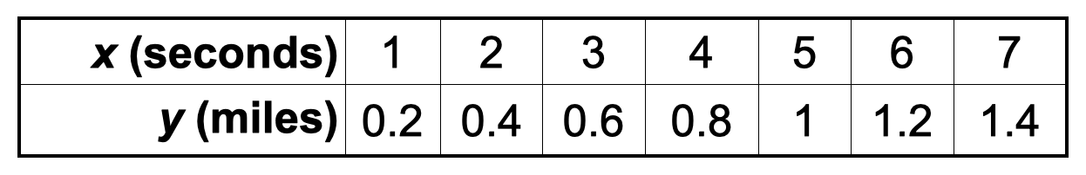

Symbolic Representation
Question: How do we represent the lightning example symbolically?

Graphical Representation
Activity: Use the graph paper to represent this function graphically.

Example

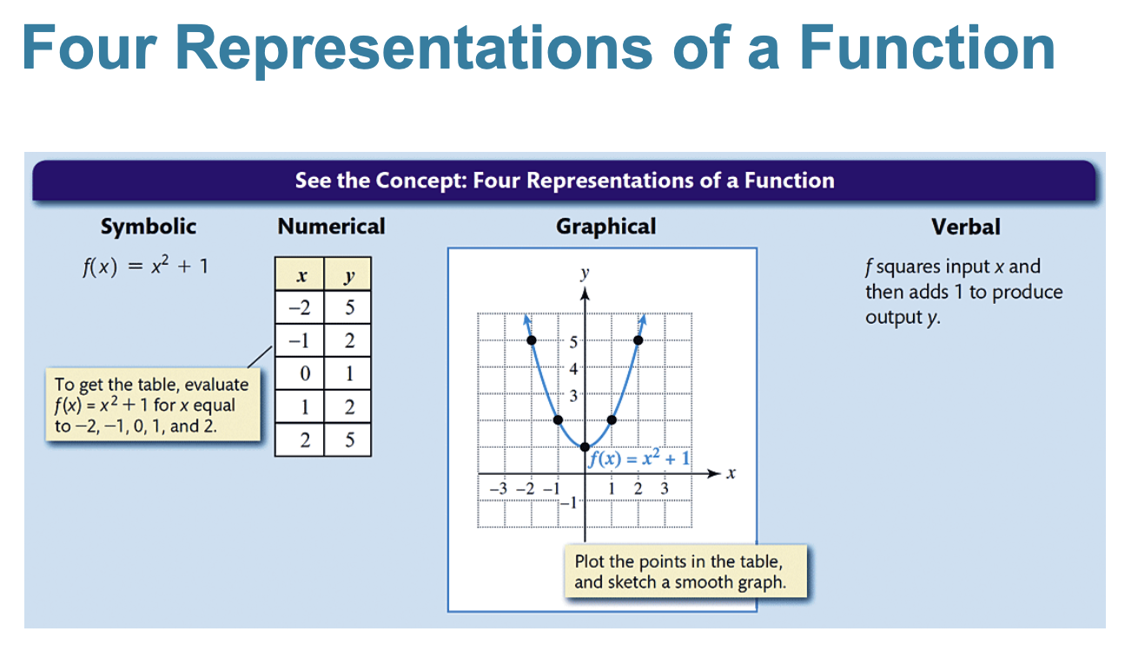
Domain: All real numbers
Range:
$\{y | y ≥1\}$

set of all y such that y is greater than or equal to 1
All y values that are greater than or equal to 1.

Example
Let a function ƒ be defined by ƒ(−1) = 4, ƒ(0) = 3, ƒ(1) = 4, and ƒ(2) = −2. Write ƒ as a set of ordered pairs. Give the domain and range.

f(-1) = 4
The point (-1, 4) is on the graph of f. For the point (-1, 4), the x value is -1 and the y value is 4.
f(0) = 3
The point (0, 3) is on the graph of f. For the point (0, 3), the x value is 0 and the y value is 3.

Domain: {-1, 0, 1, 2}
Range: {-2, 3, 4}

Set-Builder Notation

The expression {x | x > 1} is written in set-builder notation and represents the set of all real numbers x such that x is greater than 1.
Question: Is the number 2 in the set {x | x > 1}? Yes.

Question: What does the set {y | 1 < y < 5} represent?

The set of all y such that y is greater than 1 and y is less than 5
OR
The set of all y such that y is between 1 and 5, but does not include 1 or 5.

Is 6 in this set? No, because 6 is greater than 5. 6 is not strictly in between 1 and 5.

1/23/26

Set-builder and Interval notation are mathematical ways of writing a set of numbers.

"all real numbers that are at least 2"

0 1 2 3 4
<------------------------------------[------------------------>

Interval Notation: [2, ∞) "We use the bracket symbol if the number is included in the set"
Set notation: {x | x ≥ 2} "The set of all real numbers x such that x is greater than or equal to 2"

vs

(2, ∞) "This does not include 2"

"all real numbers from 2 to 5, but does not include 2 and includes 5"

0 1 2 3 4 5
<------------------------------------(----------------]-------->

Interval notation: (2, 5] "in this set, 2 is not included, but 5 is"
Set notation: {x | 2 < x ≤ 5} or {x | 2 < x and x ≤ 5} or {x | x > 2 and x ≤ 5}

Infinity is not a number, but we need to represent this in interval notation. So whenever you see an infinity symbol, you always need to use parentheses.

Example:

Represent all numbers less than 3 in interval notation. Keep in mind that 3 is not included in this set.

-2 -1 0 1 2 3
<---------------------------------------------------------)--->

Interval Notation: (-∞, 3)
Set Notation: {x | x < 3}

Activity:

Let g(x) = x² - 2x

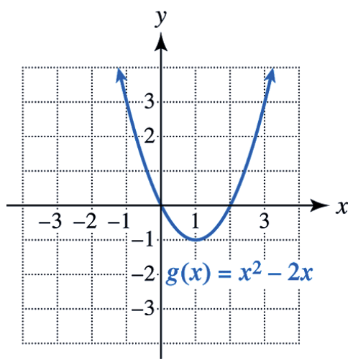

a. Find the domain and range of g. Use interval notation.

Domain: from negative infinity to positive infinity (all real numbers)
(-∞, ∞), "In set notation, R"

Range:
[-1, ∞) "In set notation, {y | y ≥ -1}"

b. Use g(x) to evaluate g(−1).

g(-1) = (-1)² - 2(-1) = 1+2 = 3

c. Use the graph of g to evaluate g(−1).
g(-1) = 3
g(2) = 0

Identifying Functions: Vertical Line Test
If every vertical line intersects a graph at no more than one point, then the graph represents a function.

Activity: Use the vertical line test to determine whether each one is a function.

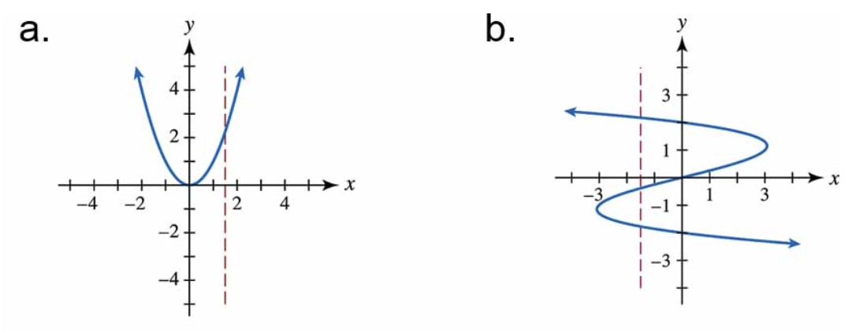
For a, yes, because you only hit the graph once. For b, this is not a function, because
the vertical line intersects 3 times.

Question: Sometimes, you get a diagram. Are these functions?
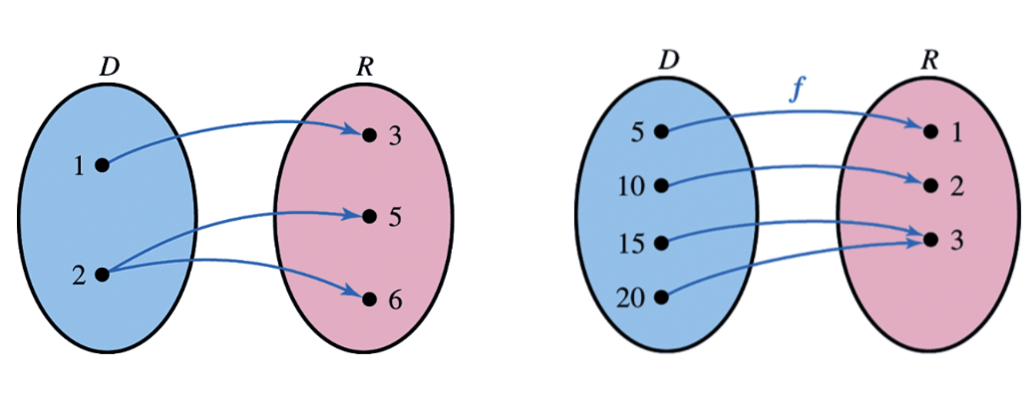

For each number in the domain, that it only maps to a single number.
For the first diagram, this is not a function, because 2 maps to different numbers 5 and 6.
For the second diagram, this is a function, because every single number just maps to 1 number.

